**IT304 : Computer Networks**

Lab 7 Introduction to RIP Protocol using Packet Tracer.

Priya Tank – 202101463

17th October, 2023

Group 5

Exercise 2:

Topology Implementation

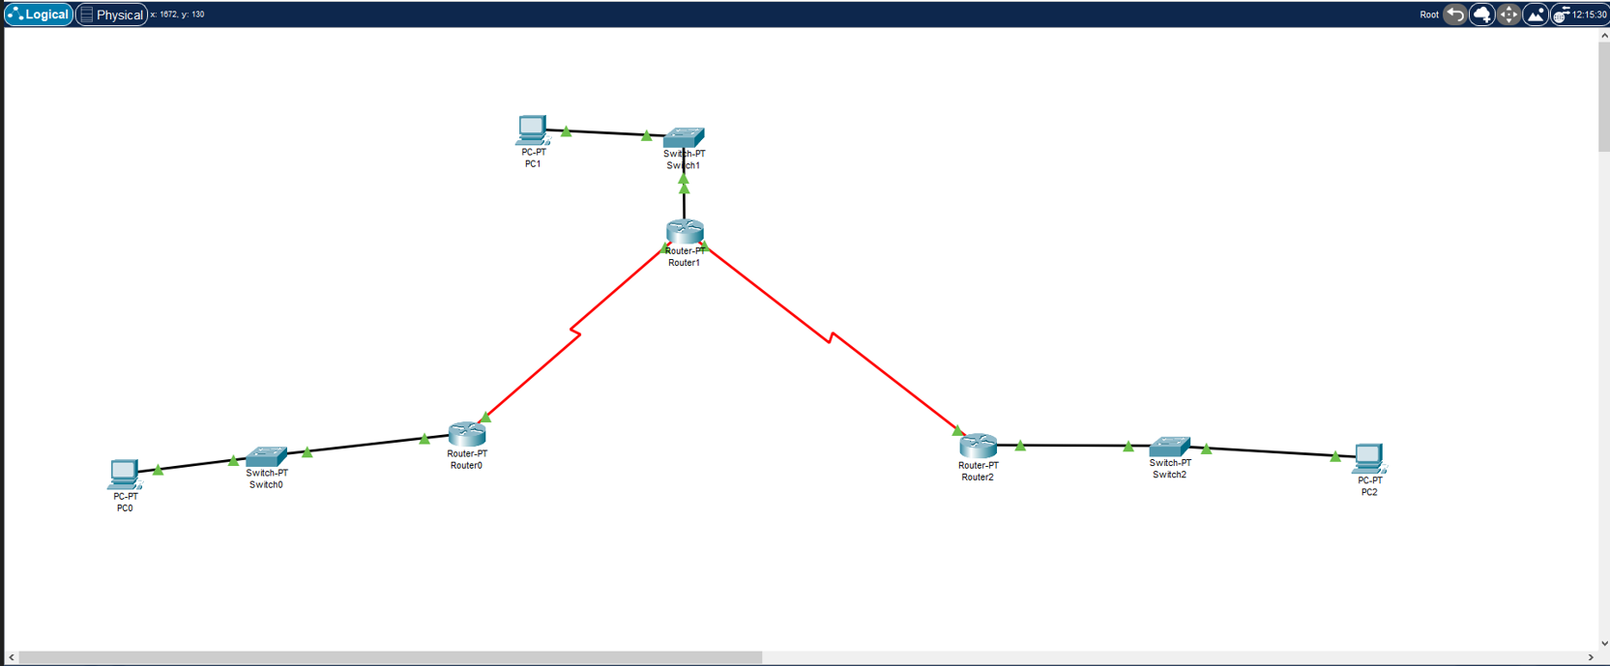

Pinging default gateways from all PC’s: -

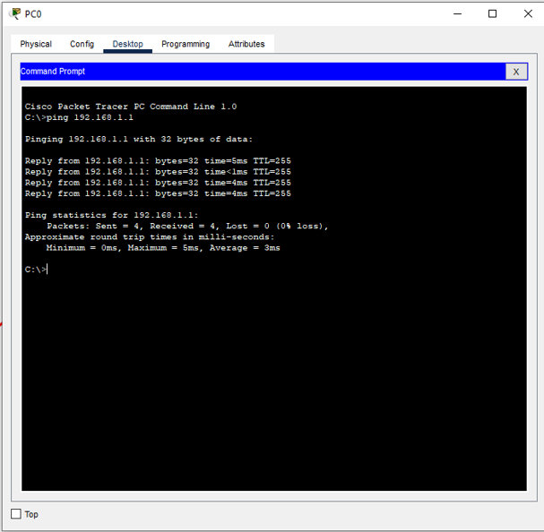 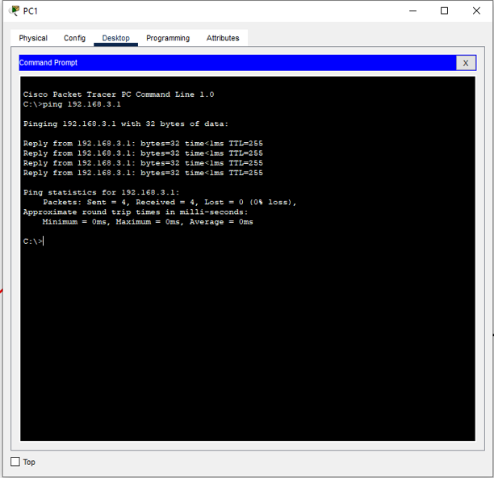

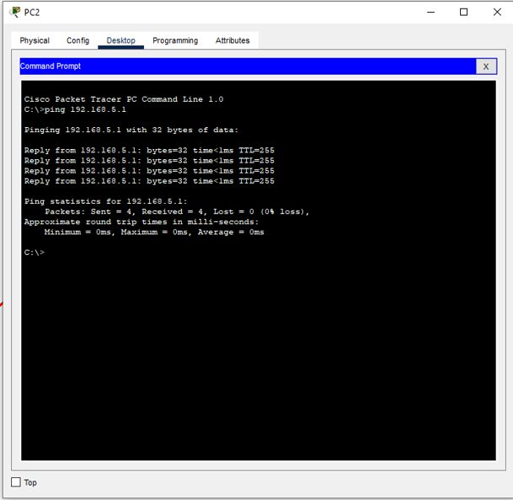

1. Display the output generated at step 5 and what is the maximum number of hops seen in the output?

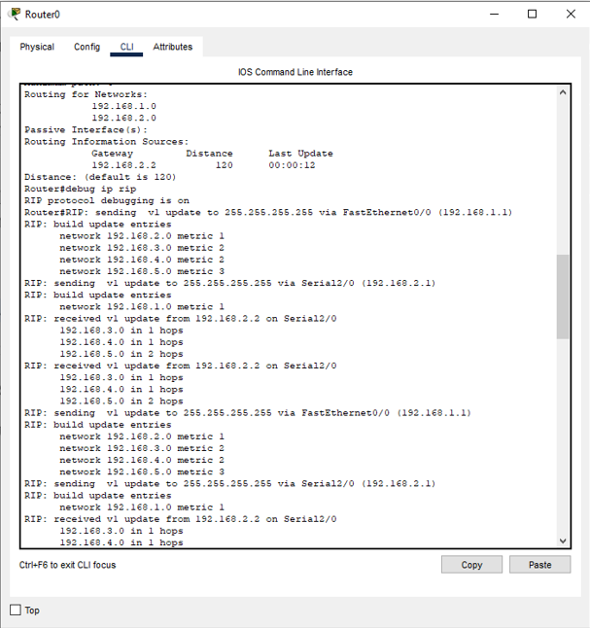

Answer:

Maximum number of hops seen in the output is 2 hops.

2. What is the administrative distance of RIP in Step 7?

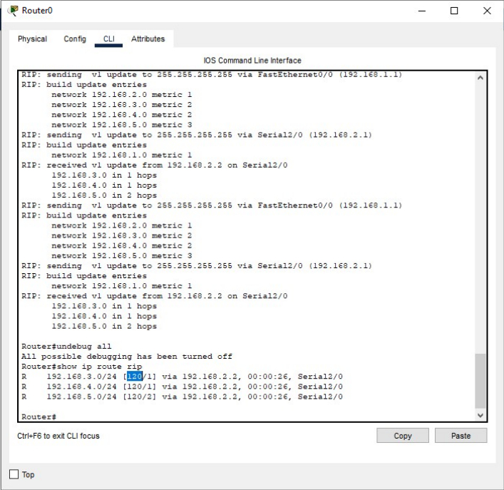

Answer:

The Administrative distance for RIP is 120.

3. When was the last update you saw in Step 8?

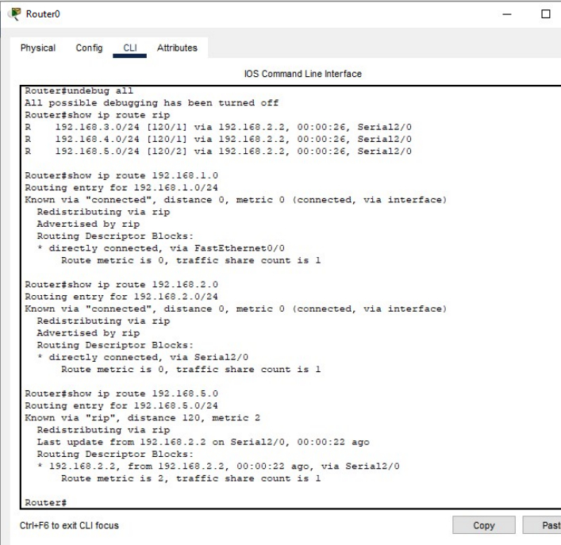

Answer:

The last update was 22 seconds ago. As shown in the image, “00:00:22 ago”.

4. What is the default update time for RIP in Step 8?

Answer:

The default update time for RIP is 30 seconds.